**Static file connection:**

**CSS file:**

**<link rel="stylesheet" type="text/css" href="{{ url_for('static', filename="styles.css") }}">**

**JAVASCRIPT:**

**<script type="text/javascript" src="{{ url_for('static', filename= "script.js") }}" ></script>**

**fhjj ffdr ksnu mzbq**

**if __name__ == "__main__":**

**app.run(debug=True)**

**Flask Flash Messages**

**{% with messages = get_flashed_messages() %}**

**{% if messages %}**

**<ul>**

**{% for message in messages %}**

**<li>{{ message }}</li>**

**{% endfor %}**

**</ul>**

**{% endif %}**

**{% endwith %}**

**{% for error in form.name.errors %}**

**<div class="error">{{ error }}</div>**

**{% endfor %}**

**For categories without form**

**{% with messages = get_flashed_messages(with_categories=true) %}**

**{% if messages %}**

**<ul>**

**{% for category, message in messages %}**

**{% if category == 'success' %}**

**<li class="success">{{ message }}</li>**

**{% elif category == 'error' %}**

**<li class="error">{{ message }}</li>**

**{% endif %}**

**{% endfor %}**

**</ul>**

**{% endif %}**

**{% endwith %}**

**Flask Flash Messages with cagtegory**

**{% with messages = get_flashed_messages(with_categories=true) %}**

**{% if messages %}**

**<ul>**

**{% for message, category in messages %}**

**{% if category == 'success' %}**

**<li class="success">{{ message }}</li>**

**{% elif category == 'error' %}**

**<li class="error">{{ message }}</li>**

**{% elif category == 'warning' %}**

**<li class="warning">{{ message }}</li>**

**{% else %}**

**<li>{{ message }}</li>**

**{% endif %}**

**{% endfor %}**

**</ul>**

**{% endif %}**

**{% endwith %}**

**Ebooks :** [**https://github.com/tecladocode/rest-apis-flask-python**](https://github.com/tecladocode/rest-apis-flask-python)

***DOCKER***

**To upload image to docker (*docker build -t rest-apis-with-flask .*) . means the floder where to you want to copy.**

**If you want to run docker file from cmd (*docker run -p 5005:5000 rest-apis-with-flask*) 5005 means the port on which you want to run the app.py**

**To know ID(*docker run -dp 5005:5000 rest-apis-with-flask*)**

***docker run -dp 5000:5000 -w /app -v "/c/Documents/yourproject:/app" flask-smorest-api***

**GENERATE SECRET KEY :**

**app.config["JWT_SECRET_KEY"] =  secrets.SystemRandom().getrandbits()**

**python**

**import secrets**

**secrets.SystemRandom().getrandbits(128)**

**Store ID:**

**from flask import Flask, request, jsonify**

**import uuid**

**app = Flask(__name__)**

**stores = {} # Initialize an empty dictionary to store stores**

**@app.route('/store', methods=['POST'])**

**def create_store():**

**store_data = request.get_json() # Get store data from request JSON**

**store_id = uuid.uuid4().hex # Generate a unique ID for the store**

**store = {**store_data, "id": store_id} # Merge store data with ID**

**stores[store_id] = store # Add the store to the stores dictionary**

**return jsonify(store), 201 # Return the created store as JSON with status code 201**

**if __name__ == "__main__":**

**app.run(debug=True )**

**GIT COMMANDS:**

[**https://git-workshop.tecladocode.com/docs/what_is_a_commit**](https://git-workshop.tecladocode.com/docs/what_is_a_commit)

[**https://git-workshop.tecladocode.com/**](https://git-workshop.tecladocode.com/)

[**https://git-workshop.tecladocode.com/docs/what_is_git_repository**](https://git-workshop.tecladocode.com/docs/what_is_git_repository)

**These all three links are indicate to Git Crash Commands which is extremely used in Git.**

**To commit or restore.**

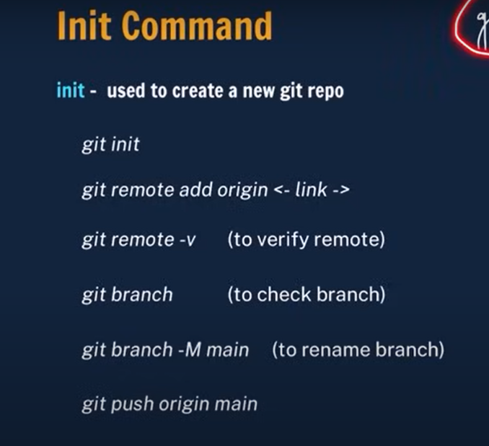 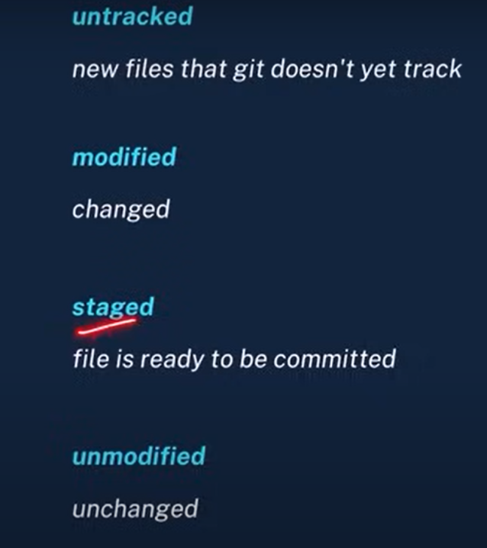

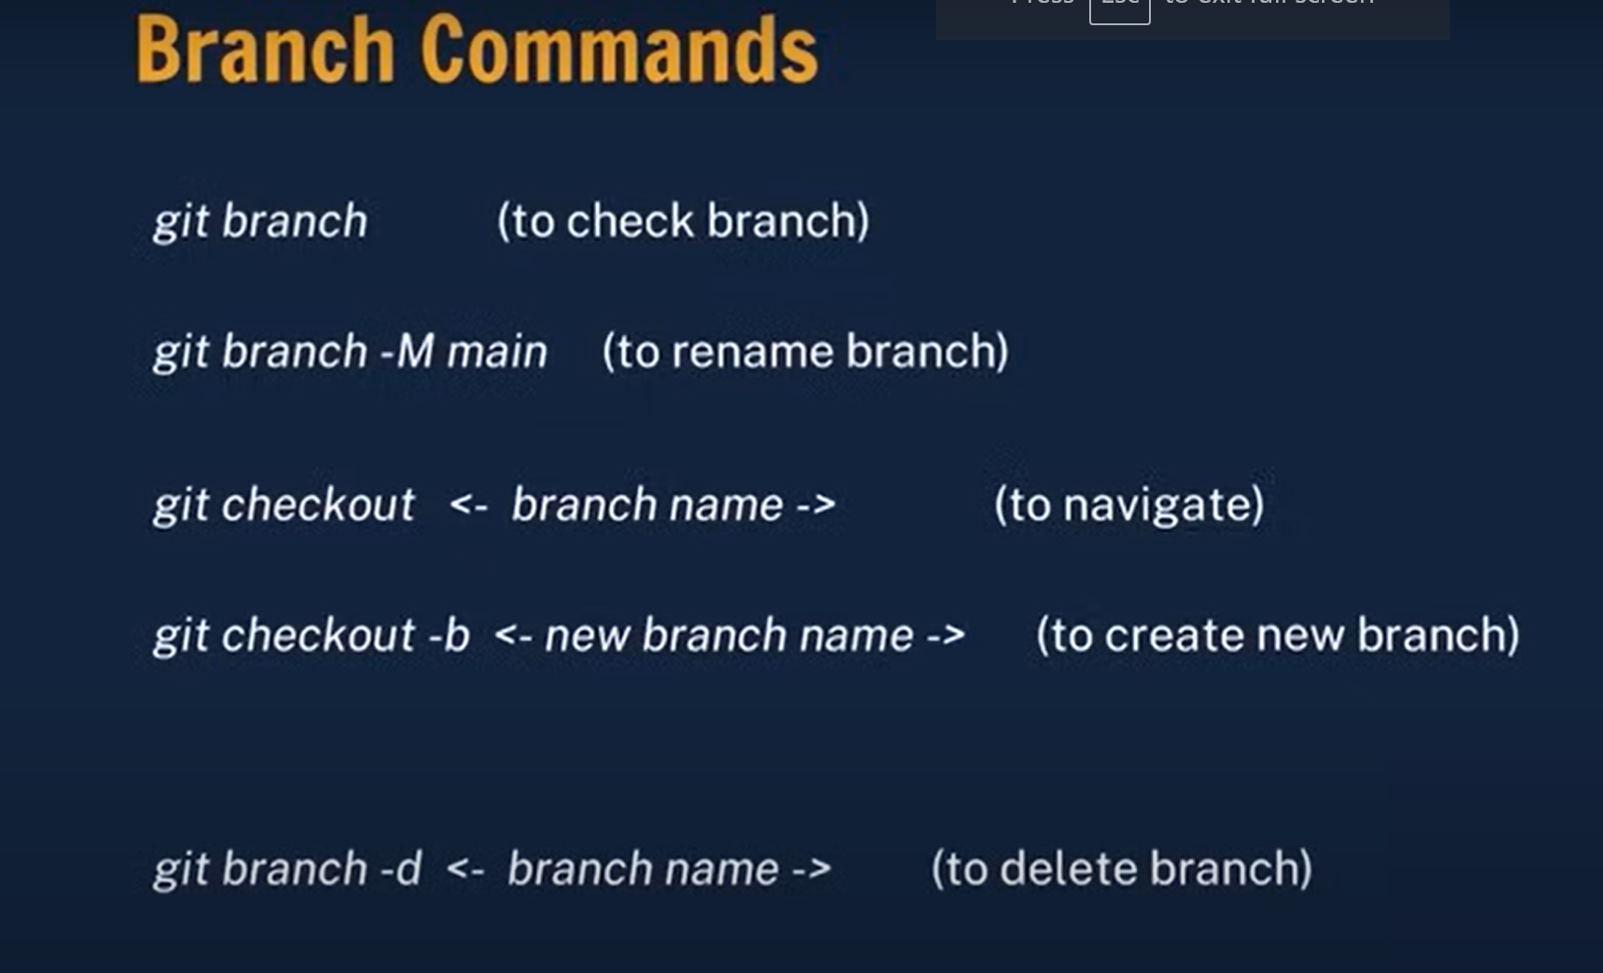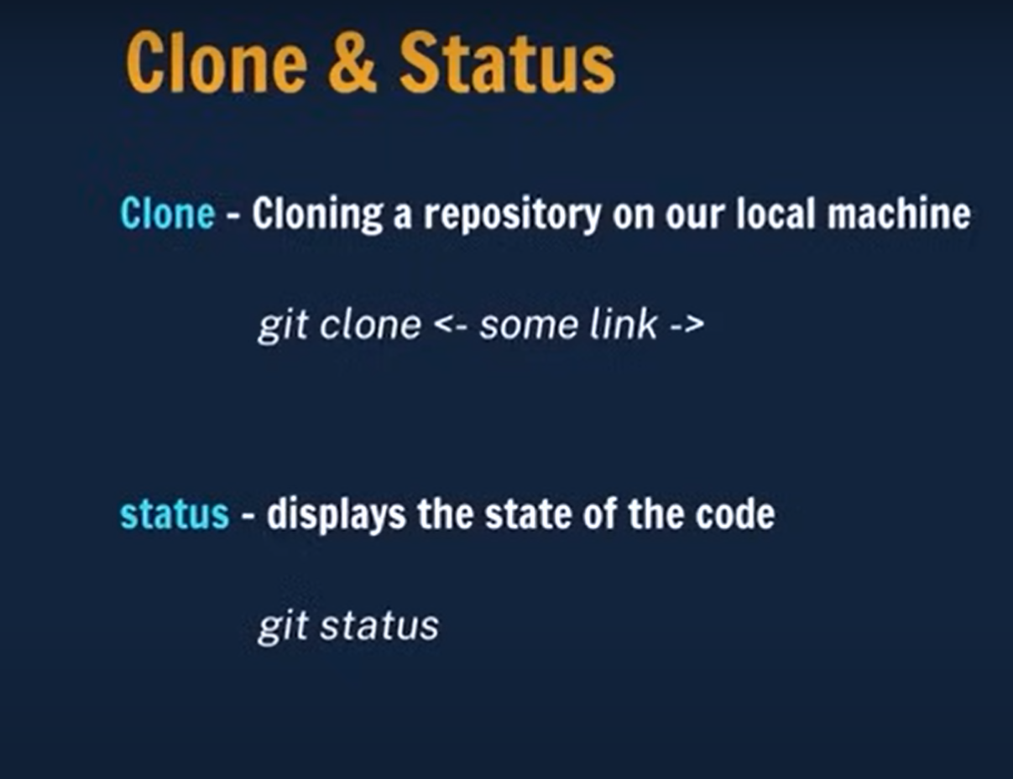



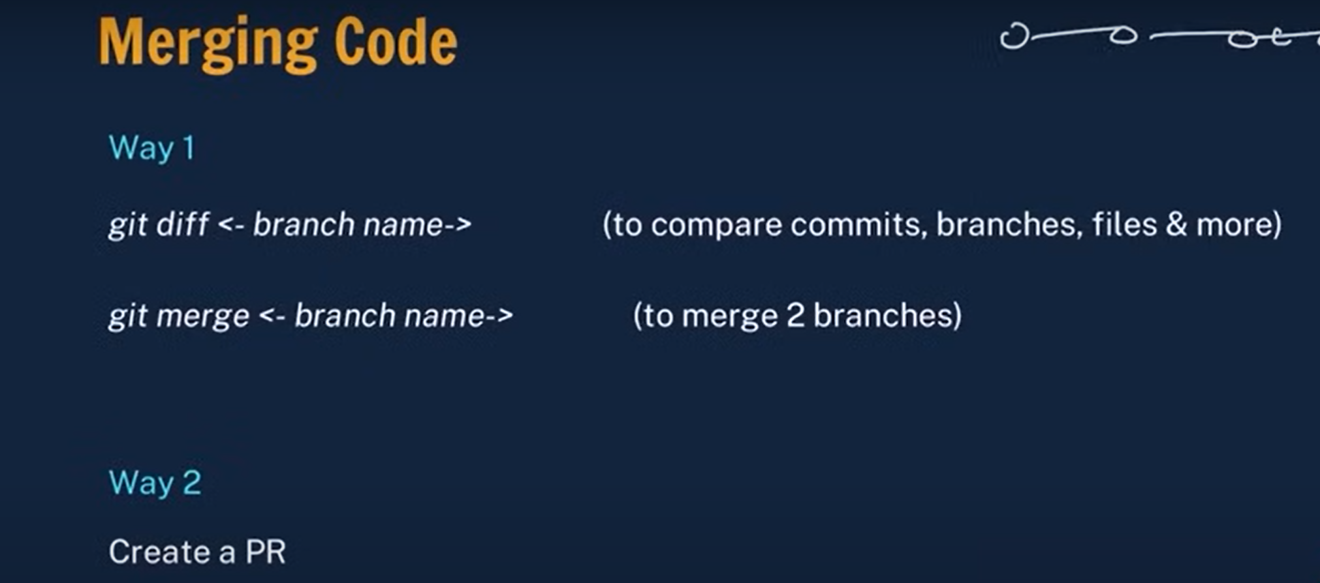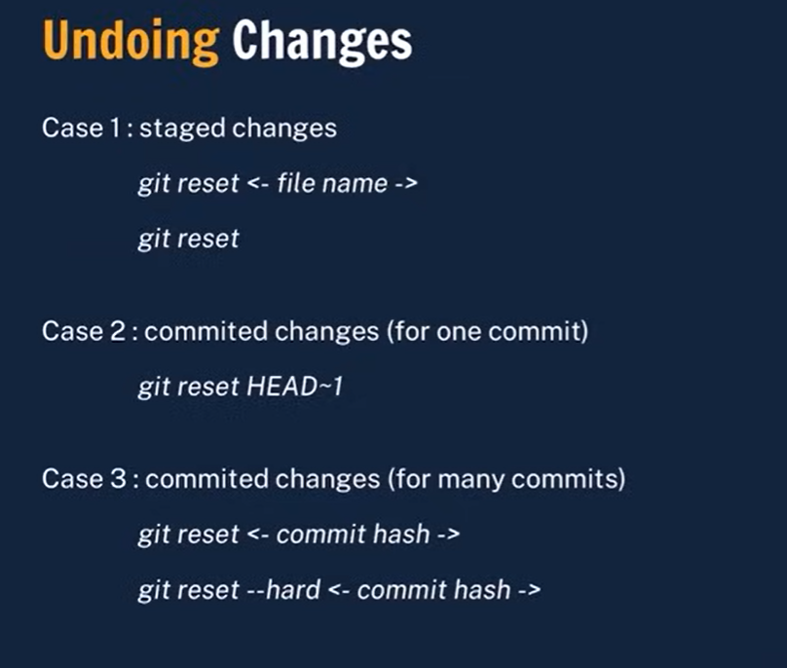

**Migration**

**flask db stamp head**

**flask db migrate -m "Initial migration"**

**flask db upgrade**